Technology & Toddlers
Directions: Download and review 3 APPS that are meant to educate toddlers (1-3 years old). Analyze, compare and contrast the APPS below.
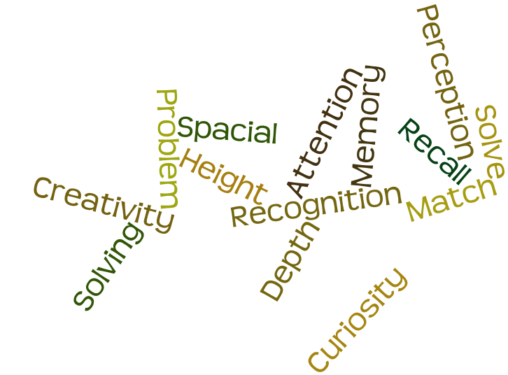
Discussion Prompt: Defend your position on whether you would let your child(ren) use Smart phone Apps when they are toddlers. Explain in detail your reasoning and alternatives if you would not.
APP PICTURE
APP NAME: __________________________________________________
- Ease of Use:
- Cost:
- Describe why this APP is age appropriate:

- What does a child consciously/unconsciously learn by using this APP?

- Positives:

- Negatives:
APP PICTURE
APP NAME: __________________________________________________
- Ease of Use:
- Cost:
- Describe why this APP is age appropriate:

- What does a child consciously/unconsciously learn by using this APP?

- Positives:

- Negatives:
APP NAME: __________________________________________________
- Ease of Use:
- Cost:
- Describe why this APP is age appropriate:

- What does a child consciously/unconsciously learn by using this APP?

- Positives:

- Negatives:
APP PICTURE

