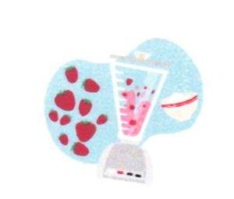
Smoothies
2-3 cups flavored yogurt
1/2 -1 cup milk
1/2 bag frozen fruit

______________________1. Measure 2 cups yogurt into blender.
______________________2. Measure 1/2 cup milk into blender.
.
______________________3. Add 1/2 bag of frozen fruit to blender.

______________________4. Place lid on blender and blend until smooth.

______________________5. If smoothie is too thin/runny, add the an
additional 1/2 cup of yogurt.

______________________6. If smoothie is too thick, add the an
additional 1/2 cup of milk.

______________________7. Pour equal amounts into glasses & enjoy.

______________________8. Wash dishes.

______________________9. Dry dishes.

______________________10. Put dishes away.
______________________11. Wipe off counters and stove.
______________________12. Sweep floors & return recipe to Mrs. G.
_______________________13. Empty garbage & Return supplies to the
the refrigerator.

______________________ 14. Put dish towels/clothes in basket after
drying the sink out.

