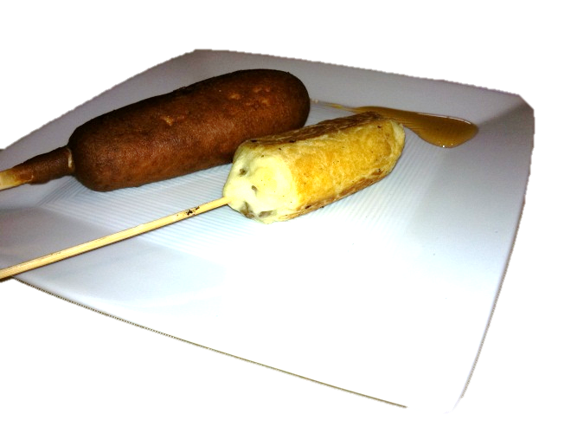
Sausage Pancake Sticks*
* Compare to Jimmy Dean's Griddle Sticks
Ingredients
- 1 1/2 cups flour
- 3 1/2 tsp baking powder
- 1 tsp salt
- 1 Tbsp white sugar
- 1 1/4 cups milk
- 1 tsp vanilla
- 3 Tbsp butter, melted
- 1 egg
- 10 skewers
- 1 box Brown ‘n Serve pre-cooked sausages, microwaved according to package instructions
- Maple syrup
Directions
- Using the quick bread method combine all the dry ingredients in a large bowl and make a “well” in the center.
- Wisk the milk, vanilla, melted butter and egg together in a separate bowl.
- Pour the wet ingredients into the dry ingredients stirring until combined. The batter should look lumpy. Don’t over mix.
- Turn cast iron skillet onto medium-high
- Skewer the sausages
- Dip the sausage skewers into the batter. Use a rubber scraper to aide in applying the batter evenly to all sides.
- Put the batter covered sausage skewer onto the hot griddle and gently turn the sausage every so often so the sides brown evenly. Remove when the batter is cooked.
- Place finished skewers on a plate in a warm oven to keep them warm while you make the rest.
- Serve with maple syrup for dipping.

