Name: Mash the Flash
Profile Description: I’m long and yellow. My one eye is bigger than the other. There’s always a smile on my face, I come in colors yellow, blue, pink, black, purple and orange.
Special Ability: I am able to keep mean monsters away in the night with my bright light.
Monster Secret: It took a while before my first glow. When I was younger I thought I never would. One day me and my friends were in trouble and I was the only one that could protect them. I was angry and scared and I tried with all my might and bam I shined so bright! The mean monsters hid from my horrific light and we were safe…thanks to my light.
Favorite game: My favorite game is hide and seek, because I can always find you with my bright light to lead the way.
Favorite food: My favorite food is lemons because they look like me and make me make a weird face.
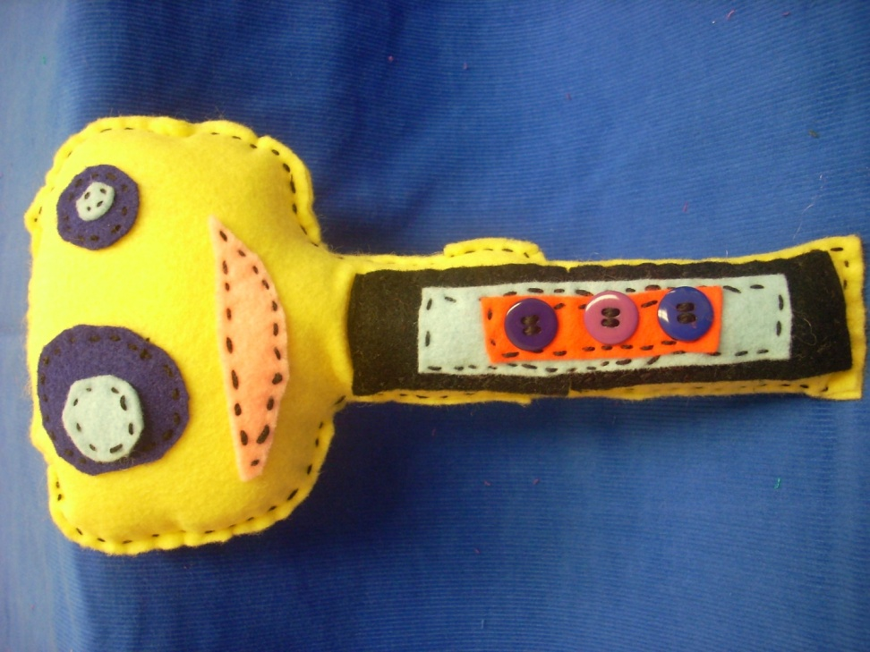
Scariest Moment Ever: My scariest moment ever was when my light went out and I was left in the dark with no one around. I was so scared that my bright fearless glow would ever return. But it did the very next day.
Honors: Even though I have no arms and legs, I can still scare those mean monsters away in the blink of an eye. I usually have a lighter glow but when I need to I shine so bright that you could see me for miles! I’m as bright as the sun.

