Name: ___________________________ Date: _____________  
Global & Gourmet Foods Name & Logo

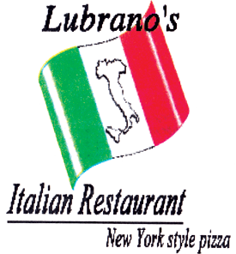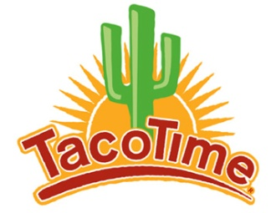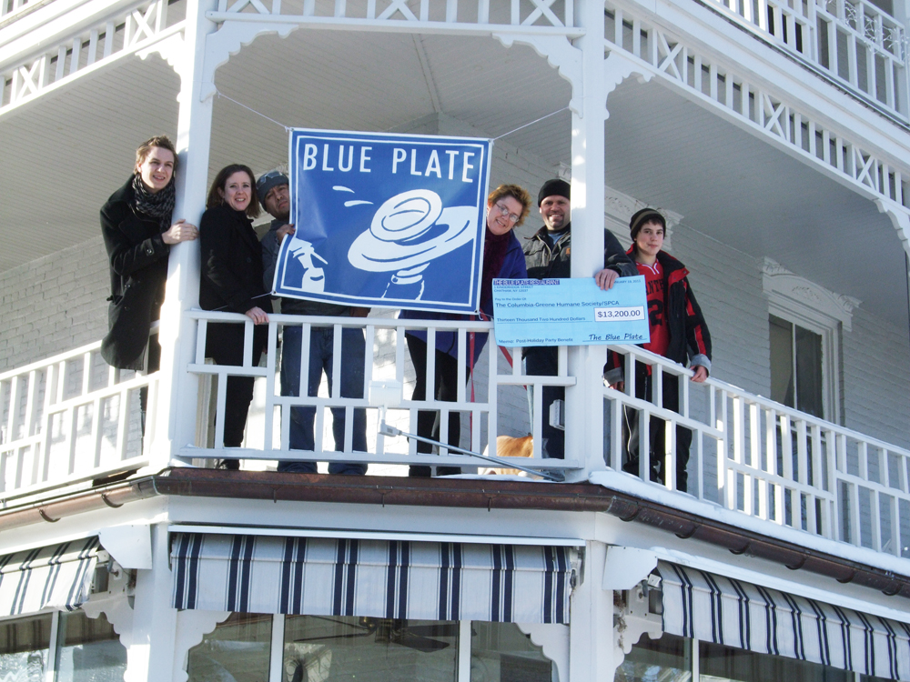Examine the following restaurant names and logos then in the space below, draw or design (using computer) your own Restaurant Name and Logo.



_____________________________________________________________