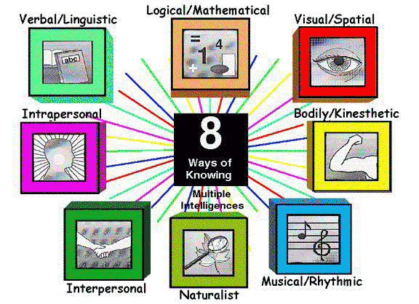
Multiple Intelligences…Student Response Sheet
Complete the following after performing the activity.

Activity 1: _______________________________________
What multiple intelligence(s) were represented in this activity?

Justify your response:

Activity 2: ________________________________________
What multiple intelligence(s) were represented in this activity?

Justify your response:

Activity 3: _________________________________________
What multiple intelligence(s) were represented in this activity?

Justify your response:

Activity 4: _________________________________________
What multiple intelligence(s) were represented in this activity?

Justify your response:

Activity 5 _________________________________________
What multiple intelligence(s) were represented in this activity?

Justify your response:

Activity 6: _________________________________________

What multiple intelligence(s) were represented in this activity?

Justify your response:

