THE LIFE OF A T-SHIRT Map Project

Directions: Using a map of the world, track the journey of the Bangladesh made T-shirt as you listen to the episodes. Secondly, track the flow of money on the map along each step.

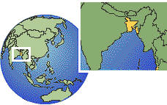

Track the flow of money: Keep track of the costs while listening to the episodes and/or reading the story on NPR.org.
- Graphic Design
- Cotton Farmer
- Yarn Spinning
- Jockey
- Printing
- Bangladesh Workers
- Kick Starter Fees
- Shipping
- Tariff on T-Shirts from Bangladesh
- Cost of Shirt to NPR (Wholesale)
- Cost of Shirt to You (retail)
- Cost to import to Kenya
- Recycled Shirt Cost to Kenyan Merchant
- Recycled shirt total cost to Tailor Shirt
- Recycled shirt cost to second merchant
- Recycled shirt cost to Kenyan consumer

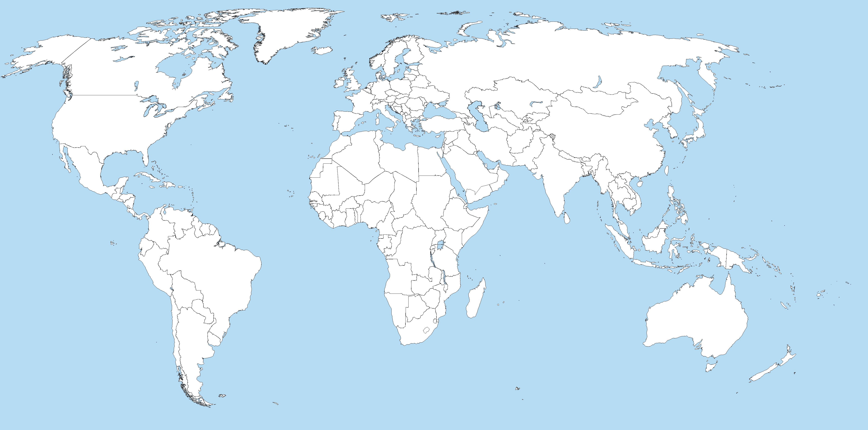

THE LIFE OF A T-SHIRT Questions

Directions: Listen to the episodes of the Life of a T-shirt series and answer the questions below.

Cotton Farming
- How has farming technology benefited the cotton clothing industry? Give three specific examples.

- How many T-shirts can be made from one US cotton farm?

Two Sisters, A Small Room And The World Behind A T-Shirt

- What are the pros and cons of the t-shirt industry in Bangladesh?

- Why does the USA have labor laws, labor unions, and building codes? What are the pros and what are the cons in light of what you’ve learned about the factories in Bangladesh? Hint: Google news articles on the Collapse of Bangladesh Factory

The Giant Book That Creates and Destroys Entire Industries
- What is a tariff?

- What happens when you increase the tariffs on T-Shirts?

- What happens when you eliminate the tariffs on T-Shirts?

- How are tariffs used for the USA’s advantage? Give an example.

- Using the USA Harmonized Tariff Schedule determine how much it would be to import a leather dog leash and leather shoelaces from China (use “general” column). Secondly determine how much the tariff on these items would cost to import if they were from either North Korea or Cuba (column 2).

Adding Up The Cost Of The Planet Money T-Shirt
- What is the largest percentage of the cost of the T-shirt?

- What costs are buried in Jockey’s costs? How much profit do you think they make per shirt?

Bonus Questions

- What are the carbon costs to making this shirt? How would you figure out what are the carbon costs of making this shirt?

- How much longer can Americans buy cheap T-shirts? What will happen if the USA cut off trade with Bangladesh? What would happen if the Bangladesh minimum wage increased?

