Granola Bar Lab

|  |  |
| --- | --- |
| 1/2c Honey |  |
| 1 Egg |  |
| ½ Cup Vegetable Oil |  |

C:\Users\Jonathan\AppData\Local\Microsoft\Windows\Temporary Internet Files\Content.IE5\Q7BIQT4X\MC900264344[1].wmf

INGREDIENTS FUNCTION IN RECIPE

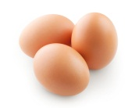

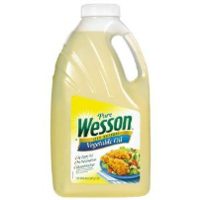

|  |  |
| --- | --- |
| ¼ Cup Brown Sugar |  |
| 1 Cup Flour |  |

C:\Users\Jonathan\AppData\Local\Microsoft\Windows\Temporary Internet Files\Content.IE5\PMEFI8LF\MC900305043[1].wmf

C:\Users\Jonathan\AppData\Local\Microsoft\Windows\Temporary Internet Files\Content.IE5\PMEFI8LF\MC900305039[1].wmf

|  |  |
| --- | --- |
| ¾ cup dried fruit |  |

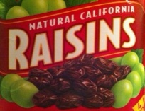

|  |  |
| --- | --- |
| ½ tsp Cinnamon, ground  ½ tsp Salt  2 tsp Vanilla |  |

|  |  |
| --- | --- |
| 1/2cup Chopped Nuts |  |
| ¼ Cup Shredded Coconut |  |

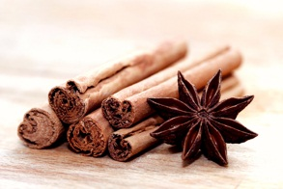C:\Users\Jonathan\AppData\Local\Microsoft\Windows\Temporary Internet Files\Content.IE5\FTINKR7T\MC900264552[1].wmfC:\Users\Jonathan\AppData\Local\Microsoft\Windows\Temporary Internet Files\Content.IE5\9K2ANS6P\MC900246157[1].wmf