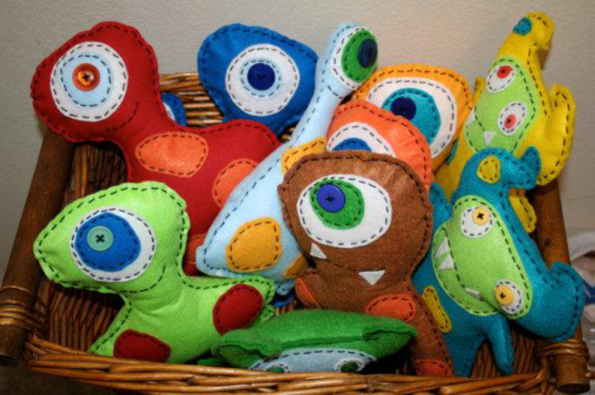
Fear-Me-Not
Community Service Project
Think about children who live in fear of “real” monsters every day such as children who live in domestically violent homes. Sometimes these children’s lives are uprooted as they head to abuse shelters with their mothers. This project might help them feel less scared and act as a form of security and comfort to them.
You will be provided two pieces of felt to create your friendly, dimensional plush Fear-Me-Not monster. You will also be provided some felt scraps, buttons and embroidery floss to help you decorate your character (you can also bring items from home). Stuffing will be provided.
Step 1: Before cutting anything, SKETCH out a pattern on blank paper that is approximately the size you want your character to be. Refer to the above picture and the below website if necessary for ideas: http://www.scaremenot.com/aboutscaremenots/heartheirstory.aspx
Step 2: Once your sketch has been approved, you will be shown how to pin and cut it out of your felt. At this time you may also cut out other felt shapes and choose embellishments. These will all have to be attached before putting the monster together.
Step 3: Once embellishments are in place, you can pin together the front and back of your monster. Stitch together using the basic running stitch. Be sure to leave an opening on the bottom or side of your character to add stuffing.
Step 4: Add stuffing so Fear-Me-Not monster is plush (not too hard or soft). Stitch up hole when stuffing is complete.
Step 5: Name your Fear-Me-Not monster and have its picture taken for the profile you are about to create.
Step 6: Write a profile about your Fear-Me-Not monster that includes:
- Name & Picture
- Profile Description
- Special Ability(ties)
- Monster Secret
- Favorite Game
- Favorite Food
- Scariest Moment Ever
- Honor(s)
Note: Refer to the referenced website if you need to see a sample.
Remember this is a community service project and these will be donated to the ABUSE NETWORK. Therefore, do your BEST work and take your time!

DATE DUE:__________________________

Name______________________________________________________
Fear Me Not Rubric
Criteria | Points | Self | Teacher
Pattern—cut neatly from paper | 5
Cutting—pinned & cut evenly | 10
Embellishments—neatly cut & sewn securely in place | 10
Embroidery—neat & even stitches with hidden knots | 10
Stuffing—not too hard or too soft | 10
Creativity—design & profile are original & very creative | 20
Neatness—project is neat & clean | 10
Work Habits—good use of class time | 20
Typed Profile—created in WORD or Publisher—one page in length & free of spelling/grammatical errors | 20
Photo—digital photo inserted into profile document | 5
Total Points Earned—out of possible 120
Comments:

