Buffalo Chicken Wings Recipe

Ingredients
- 8 Fresh Chicken Wings (4 person lab group)
- Deep Fryer & Oil

- 4 Tbsp. Butter
- ½ tbsp. Garlic Powder or one clove of fresh garlic, minced
- 1 Tbsp. White Vinegar
- 4 Tbsp. Hot Sauce
- Salt & Pepper, to taste

Directions
- Preheat deep fryer to 375F.
- Wash & thoroughly dry chicken wings. Cut off wing tip and separate wing from drummettes.
- Deep fry wings in 375F oil, until crispy and internal temperature reaches 165F.
- On low heat melt butter and cook garlic. Wisk in the rest of ingredients.
- Taste sauce for heat preference. The 1 to 1 ratio is a fairly mild wing sauce. Decrease the amount of butter for a hotter sauce.
- Drain chicken wings on paper towels to mop up excess oil.
- Place wings in bowl or pot of sauce and gently swirl to coat.
- If you like dry wings place saucy wings on greased cookie sheet and bake at 350F for 15 minutes.
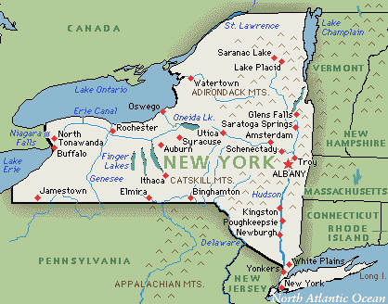
- Plate your chicken wings.
1964
Did you know Buffalo wings originated in Buffalo, NY when Teressa Bellissio, a restaurant co-owner, made them for her son and his friends? At that time chicken wings were considered useless and usually thrown out by restaurants or made into stock.

