Southwestern Veggie Burgers
Makes 8 Burgers
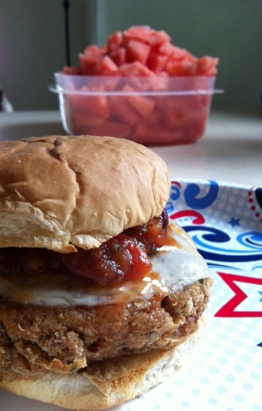
Ingredients
- 1 cup uncooked white quinoa
- 15oz can Kidney beans, drained
- 1 medium onion
- ¼ cup green chilies chopped
- 1 egg
- 2 cups bread crumbs
- 1 Tbsp garlic powder
- 1 tsp chipotle powder
- 1 cup shredded sharp cheddar cheese
Directions
- Preheat oven to 400F.
- Bring 3 cups of water to boil. Add quinoa and cook for 15 minutes or until “sprouted” looking.
- Meanwhile quarter onion and chop in food processor.
- Add drained kidney beans, green chilies, egg, garlic powder, chipotle powder, and cheese to the food processor and pulse into paste.
- Drain quinoa and add to food processor. Pulse until mixed.
- Transfer mixture to a bowl and add bread crumbs. Mix thoroughly.
- Form hamburger size patties out of the mixture.
- Bake on an oiled cast iron skillet or cookie sheet for 8 minutes. Flip burgers over and spray the pan under the burgers with cooking spray so they don’t stick on the other side.
- Prepare your burger fixings and melt cheese on the burgers during the last minute of cooking if desired. These burgers are great with lettuce, black olives, jalapenos, and salsa!

