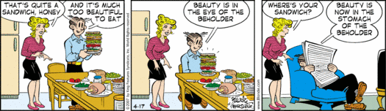Sandwich Glog
Choose a type of sandwich to research. My selected sandwich is _____________________.
Your glog should include the following about your sandwich:
- Title (Sandwich Name)
- History of your sandwich
- How it got its name
- Recipe for your sandwich (link if space is an issue)
- Photo(s) of your sandwich
- Food Groups your sandwich represents
- Poem about your sandwich (any style)
- Citations for information/pictures used (copy & paste URL’s)
In Addition to the Glog….
Type up 5 questions about your sandwich to use as a review after presentations…give me them separately.
See reverse side for rubric….

Name___________________________Date Due____________
Rubric
Criteria x3 | Present | Not Present

Title:
History of Sandwich:
Invention of Name:
Recipe:
Food Groups Identified:
Photo(s):
POEM:
Citations:
Five Questions:
Free of Spelling & Grammar
Errors:
Not too Busy or Cluttered:
First Name on Glog:

Comments:

Sandwich Sign Up:
Name of Sandwich Person
Po’ Boy
Submarine
Club
Philly Cheesesteak
Dagwood
Cuban
Gyro
Monte Cristo
Rueban
Sloppy Joe
Tuna Melt
Hamburger
Hotdog
Taco
Runza
Caprese
BLT
Muffuletta
Sample Sandwich Glog:
http://primitivekim.edu.glogster.com/panini/

