Red & Green Chocolate, Chocolate Chip Cookies
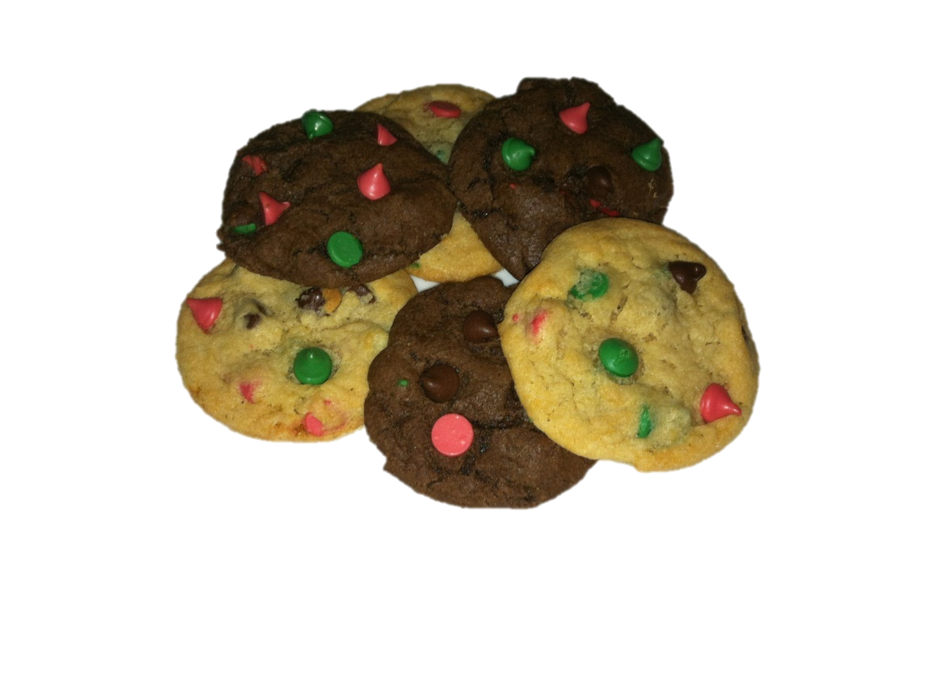
Ingredients
- 1 stick soft butter
- ½ cup brown sugar
- ½ cup white sugar
- 1 egg
- 1 tsp vanilla
- ¼ cup cocoa powder
- 1 ½ cup flour
- ½ tsp baking powder
- ½ tsp baking soda
- ½ tsp salt
- 1 bag Nestle Christmas Red & Green Chocolate Chips
Directions
Cream butter and sugars. Beat in egg and vanilla. Stir in dry ingredients and chips. Drop rounded tablespoons onto greased cookie sheets. Flatten slightly. Press chocolate chips onto outside of cookie so you get more colorful finished cookies. Bake 350F for 7-9 minutes.

