Poinsettia Christmas Cookies
Ingredients
- 1 1/2 cups butter, softened
- 2 cups sugar
- 1 box red jello any flavor
- 4 eggs
- 1 tsp vanilla
- 1 tsp salt
- 2 tsp baking powder
- 5 cups of flour
Directions
1. Preheat oven to 350F. Cream butter and sugar. Add jello.
2. Beat in the eggs, one at a time.
3. Stir in the remaining ingredients.
4. Roll dough into golf ball size balls. Refrigerate for at least one hour.
5. Using kitchen scissors cut the dough four times (equal spacing) being careful not to cut all the way through the ball. Leave about ¼” intact.
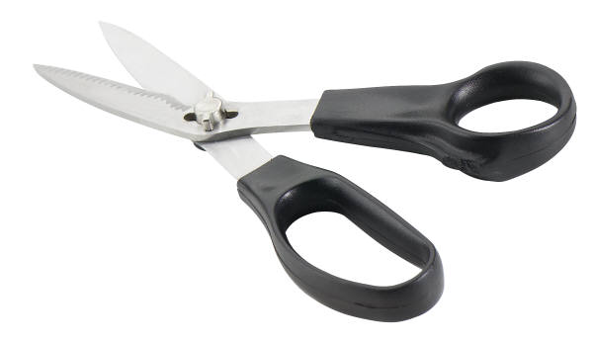

6. With your fingers gently separate the petals and flatten them slightly.
7. Sprinkle yellow dot sprinkles in the center of each flower cookie.
8. Bake for 6-8 minutes. Let cool completely before attempting to move.

