Name: ____________________________________ Date: ______________
Global & Gourmet Foods Menu

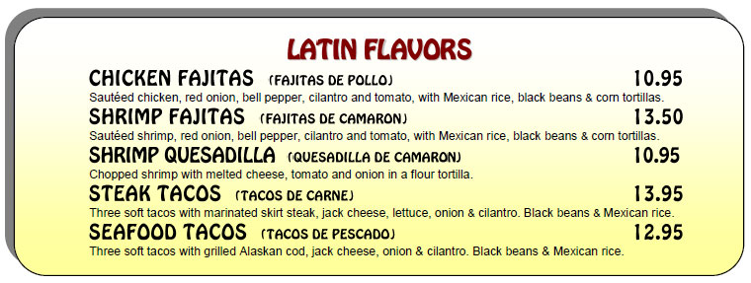
Using a computer, create a menu for your restaurant. It must include section headings, a description of the dish, and the cost of the dish. See example below:

Think about the following questions when putting together your menu items:
Will you have daily specials?
Will you offer a different soup on different days?
Will you have an up charge for added cheese on a burger? Fries?
Will you offer free refills on fountain beverages?
Will you serve breakfast items all day?
Will you have combo- meals?
Do certain dishes come with soup or salad? Fries? Chips & Pickle?
Will you have a Senior Citizens special menu/pricing section?
Will you have a separate Children’s menu or add it to the original?

Don’t forget pictures of the food items to entice your diners!

Several menu templates are available on the G Drive Hayes
GGF Restaurant Project.

Create on computer, print and fold. Turn in.

