**Muffin Lab Leavening Agents Experiment Results**

**Directions**: Look at a muffin from each lab group and fill in the chart below with descriptive observations.

|  |  |  |  |  |  |
| --- | --- | --- | --- | --- | --- |
| **Leavening Agent** | **None** | **Baking Soda & Vinegar** | **Baking Soda** | **Baking Powder** | **Yeast** |
| Height |  |  |  |  |  |
| Color/Appearance |  |  |  |  |  |
| Air Pocket Consistency (cut muffin in half to see air pockets) |  |  |  |  |  |
| Taste |  |  |  |  |  |

**Directions:** Answer the Questions below. Refer to your text book for help.

1. Why didn’t the yeast muffins rise as much as some of the muffins that used chemical leavening agents?
2. What is the purpose of leavening agents? What happens when they are not used?
3. Describe any possible sources of error in this class lab experiment.
4. How do you choose the acid in a recipe to react with the baking soda? Was vinegar a good choice? What would have been better?
5. What is the acid in baking powder?
6. Find two recipes for each category of leavening agents. Circle the leavening agent in each recipe.

PhysicalC:\Users\Melanie\AppData\Local\Microsoft\Windows\Temporary Internet Files\Content.IE5\DAPPLWGF\MC900389376[1].wmf

Biological 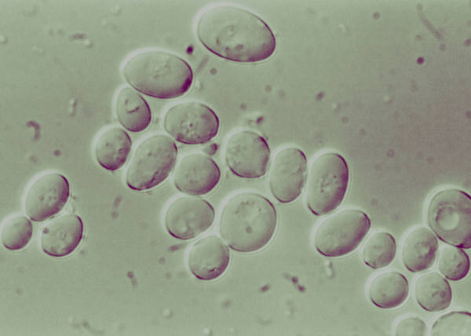

Chemical 