Food Aliments
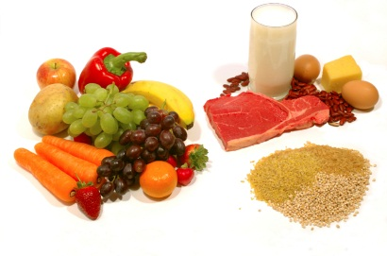
Directions: You are a nutritionist and each of the clients below needs your help to come up with a diet that they can live with in light of their current medical condition. Create a menu for one week that fits your client. Create a packet to give your client including a letter explaining his/her condition and causes, a week’s menu with recipes and specific brands (if necessary).

Cindy: has been recently diagnosed with celiac disease. She loves cheese pizza and is a vegetarian.

Adam: is 65 years old and has been told by his doctor that he has high cholesterol. Adam would prefer to lower his cholesterol naturally by changing his diet rather than going on prescription drugs. Adam does not like vegetables and drinks a beer daily.
Natasha: was feeling so upset for weeks that she got tested for food allergies. She was diagnosed as being lactose in tolerant. Her family cannot afford the pills that would allow her to eat dairy nor can they afford elaborate meals. Help her find an inexpensive diet she can live with.

Pedro: is a college engineering student who is completely overwhelmed with school. He is an emotional eater—that explains his 20lb weight gain since the beginning of the semester. He likes to snack while studying and there has been a lot of studying this semester. His doctor told him he needs to lose weight and find a new way to deal with stress.

Takesha: age 7, is severely allergic to dairy products and soy milk too. She doesn’t have grown up tastes in food yet.

Jared: is severely overweight 11 year old diagnosed with Prader-Willi syndrome. He loves eating just about everything but his parents are concerned he could eat himself to death.

Max: is 17 and was diagnosed with type 2 diabetes. He loves potato chips, ice cream, candy bars, soda, and bagels and doesn’t want to give up all he loves for a diet.

Audrey: is 75 years old and was recently hospitalized for a condition called diverticulosis. She loves picking fresh berries from her farm and sipping her warm cup of coffee every morning.

