Food borne illness animoto Name___________________
Date Due________________
You and your partner have been given the task of uncovering important documentation about serious FBI criminals known to man. These FBI criminals have been on the “Most Wanted” lists for years. It will be your job to create a profile on an FBI to help officials catch these deadly criminals.
Step 1: FBI (food borne illness) to research is ____________________________.
Step 2: Use in class resources and the internet to fill in the information about your assigned FBI on the “Most Wanted” form.
Step 3: Use the information gathered to create an “ANIMOTO” slide show about your FBI. It must be 12 slides (30 seconds) in length and include the following:
- FBI Name
- Photo(s) of FBI (even if invisible to the naked eye)
- Hideouts
- Crimes
- Prevention
Step 4: Email your completed ANIMOTO to ______________ with you and your partner’s name in the message box. You will be given 2 class periods to complete this assignment….use it wisely! Be sure to turn in your “Most Wanted” form along with this paper for the rubric.
Animoto Rubric:
Criteria 5 Points Each | Present | Not Present
Uses 12 slides total

Appropriate Text & Graphics

Theme/Mood Related Music Choice

Info about FBI Conveyed

Photos are Clear

All Criteria Included

Total Points (30 possible
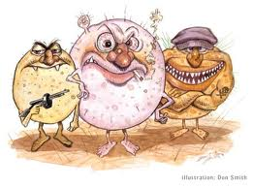
FOOD BORNE ILLNESS
most wanted
As you research information about your FBI, please fill out the following in complete sentences and with detail. I will use this as my guide when grading your ANIMOTOS.

NAME OF FBI_______________________
HIDE-OUTS: Where is it found? What are its sources food or otherwise?

Crimes: What are the symptoms if you get this food borne illness?

Prevention: What can we do to outsmart them?

