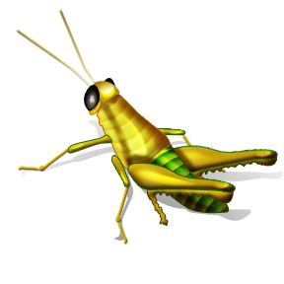
Entomophagy
- Define Entomophagy:

- List 10 insects that are safe to eat?

- What countries eat bugs?

- List the name of three recipes for different insects?

- Who should not eat insects? (hint allergies)

- What is the nutritional value of insects?

- What are the FDA rules regarding bugs in our food?

- What are some things to take in consideration before trying to eat insects or cook with them?

