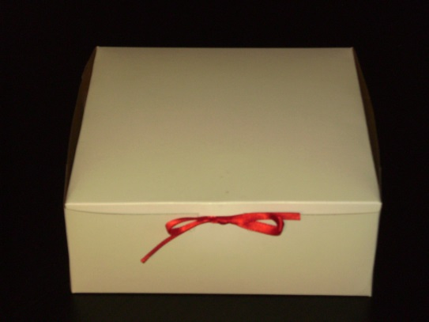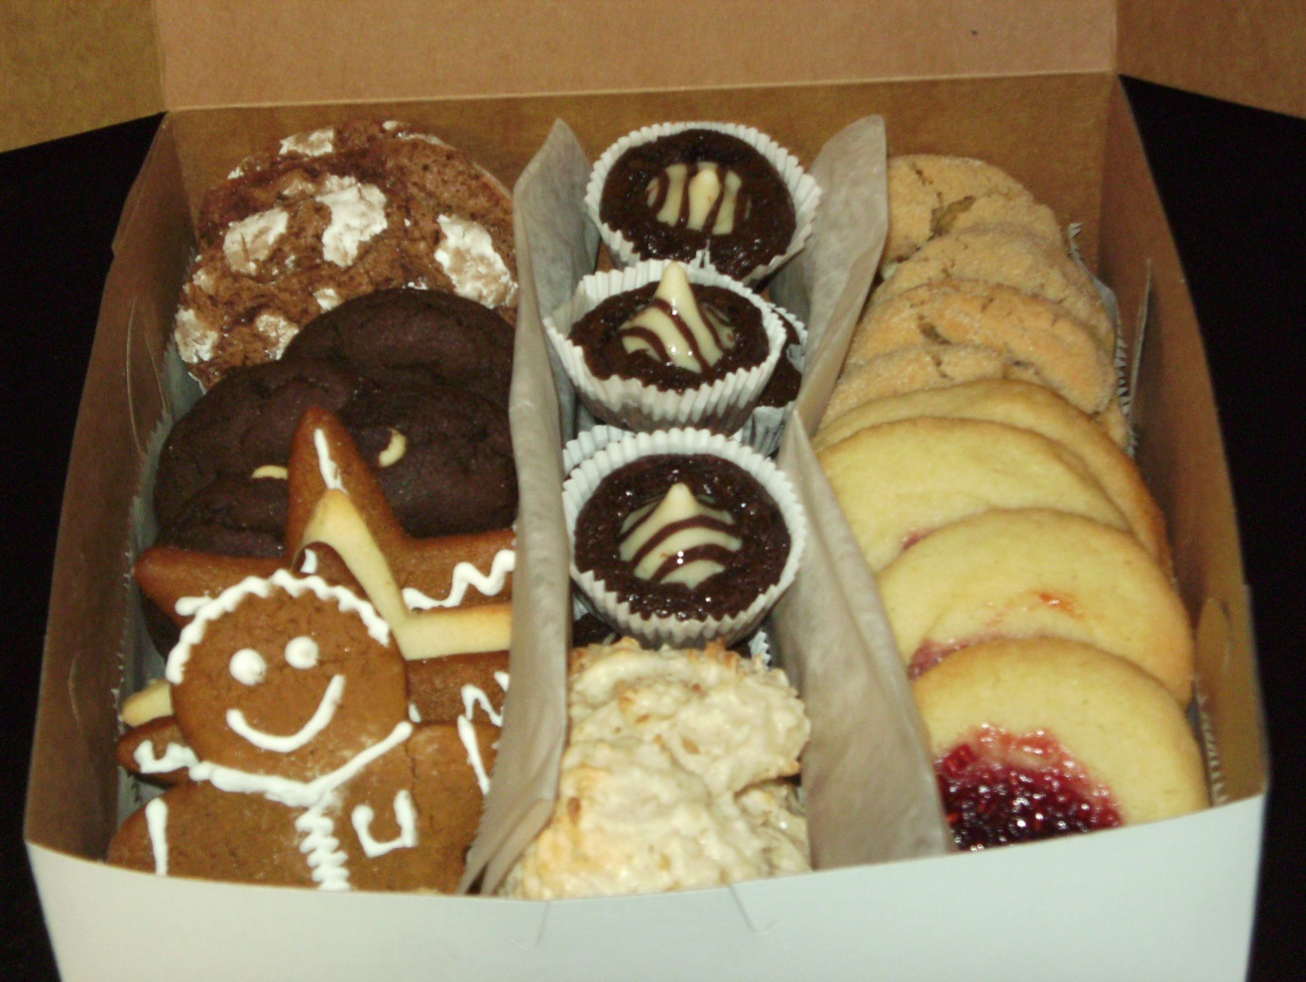Culinary Arts Holiday Cookie Fundraiser

Help Support the Culinary Arts Department

Purchase an 8x8x3” box of approximately 36 cookies- 7 varieties for only $10.00!

**Varieties Include:**

* Raspberry Thumbprints
* Gingerbread
* Sugar
* Coconut Macaroons
* Peppermint Teacakes
* Chocolate
* Peanut Butter Blossoms

All cookies are made from scratch by our Culinary I students; giving our students a chance to learn mass food production.

**Please enclose Cash or Check payable to Culinary**

Name: ________________________________

Email: ________________________________

Phone: ________________________________

# of Boxes ________ * $10 = $___________

**Pick up your Box of cookies**

**Friday, December 18th Room A118**

Place order form in culinary mailbox. Please enclose payment at time of order.