Name: ___________________________________ Date: ________________
Global & Gourmet Foods Commercial

Using Windows Moviemaker create a commercial advertisement for your new restaurant. Your saved commercial should play in Windows Movie Maker. Please save it to the Common Folder Hayes and to your own folder as a backup.

- To create a commercial, decide if you want it to be:
  - Images and text
  - Video and text
  - Images, Video and text
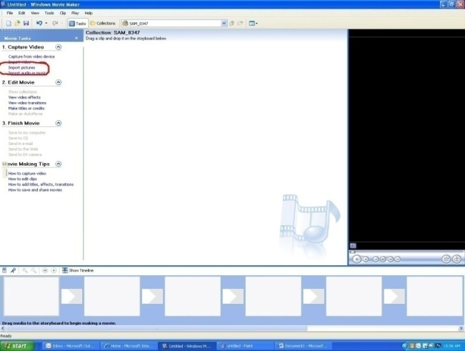
  - Shoot your video footage and/or collect/take your images. Import them into Moviemaker
- Crop and edit your video and/or images.
- Add text (Click on Make Titles or credits)
- Preview your commercial.
- Record your voice in Audacity (Mr. Flanagan’s room is equipped with this program and microphones if needed) as your commercial plays (so the timing matches). Save your Audacity voice recording as a .WAV file.
- Import your .WAV voice recording into your Moviemaker project.
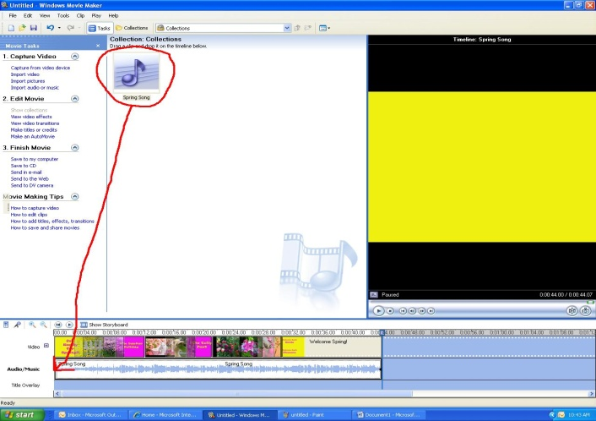
- Import an MP3 music file to play in the background of your commercial (if you want) or as your theme song. Add your song by dragging it down to the Timeline, in the second row Audio/Music.

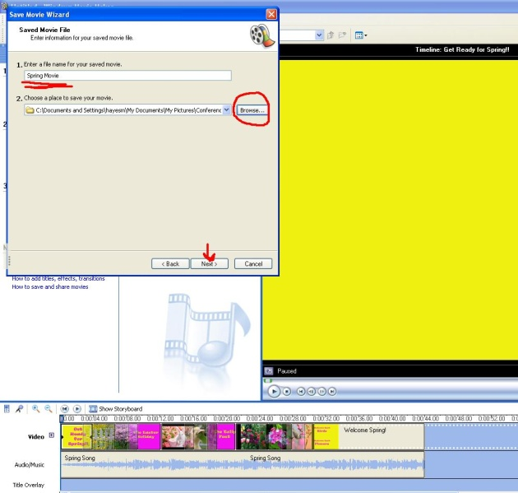
- When all editing is complete, save and export your Moviemaker commercial as a .WMV file. Make sure it is in the Common Folder Hayes.

