Christmas Pistachio Cookies
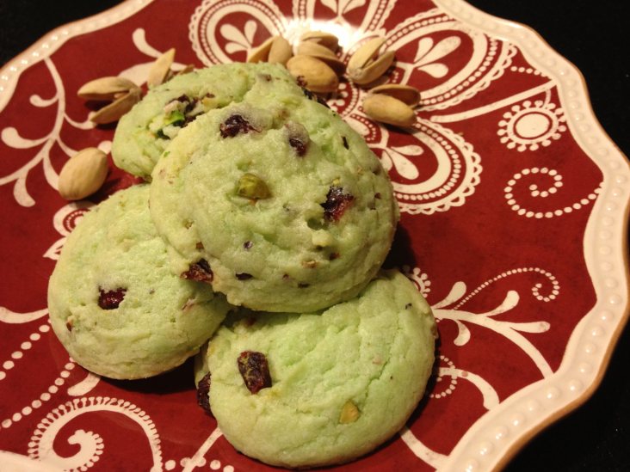
Ingredients
- 1 ½ cups butter, softened
- 2 cups sugar
- 4 eggs
- 1 tsp vanilla
- 1 tsp salt
- 2 tsp baking powder
- 5 cups flour
- 2 boxes Jello Pistachio Instant Pudding Mix
- 3/4 cup pistachios, roughly chopped
- 1 cup craisins, roughly chopped

Directions
- Preheat oven to 350F.
- In a large bowl cream butter and sugar. Beat in eggs one at a time. Stir in pudding mix.
- Mix in remaining ingredients.
- Use cookie scoop to form dough into balls.
- Place on greased cookie sheet. Bake for 8-10 minutes until cookie is “set” in the middle.

Makes approximately 40 cookies

